**TEST CASES DESIGNED FOR THE FUNCTIONALITIES IMPLEMENTED IN YOUR PROJECT**

**SMART RETAIL: VOICE-GUIDED STOCK MONITORING VISUAL BILLING**

**AND IMPORT RECOMMENDATIONS**

**Test Case 1: Add New Product**

* Objective: Verify the ability to add a new product to the product list.
* Precondition: The user is logged in, and the product list is displayed.
* Steps:
  1. Click on the "Add New Item" button.
  2. Fill in all the required fields in the form (name, price, category, quantity, low stock alert, image URL).
  3. Submit the form.
* Expected Result: The new product appears in the product list with accurate details.

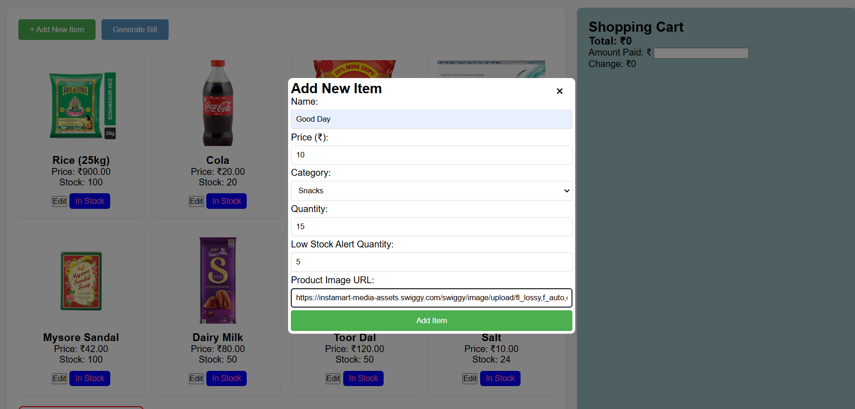

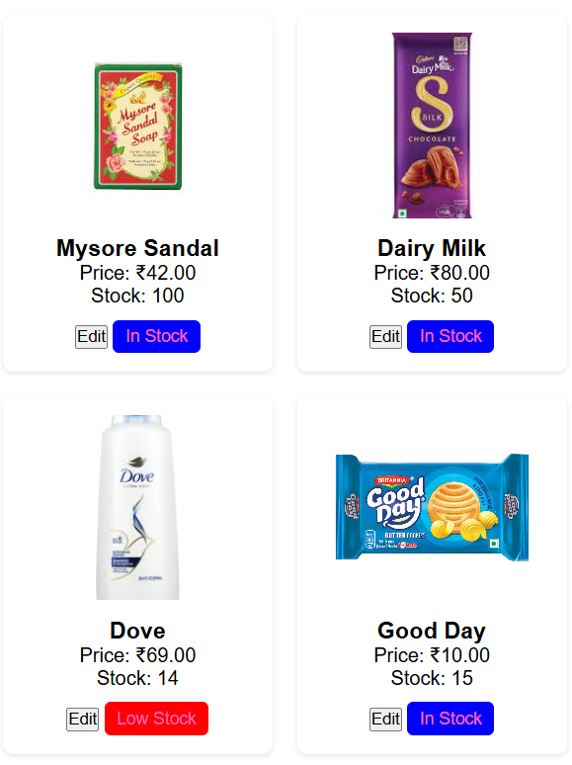

**Test Case 2: Filter Products by Category**

* Objective: Ensure products can be filtered by category.
* Precondition: Multiple products exist in different categories.
* Steps:
  1. Click on a category button, e.g., "Food".
* Expected Result: Only products belonging to the selected category are displayed.

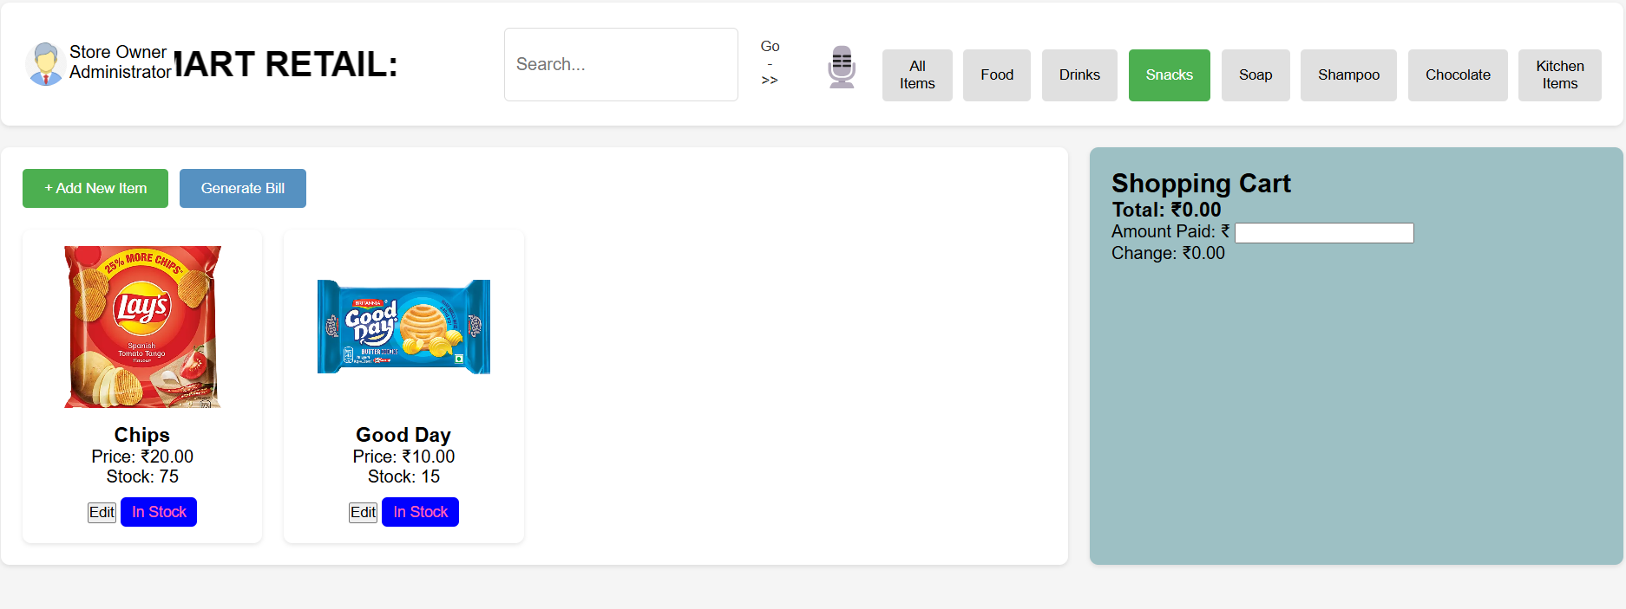

**Test Case 3: Add Product to Cart**

* Objective: Confirm that a product can be added to the shopping cart.
* Precondition: At least one product is in stock.
* Steps:
  1. Click on the product image of an in-stock product.
* Expected Result: The product is added to the shopping cart, and its details are displayed.

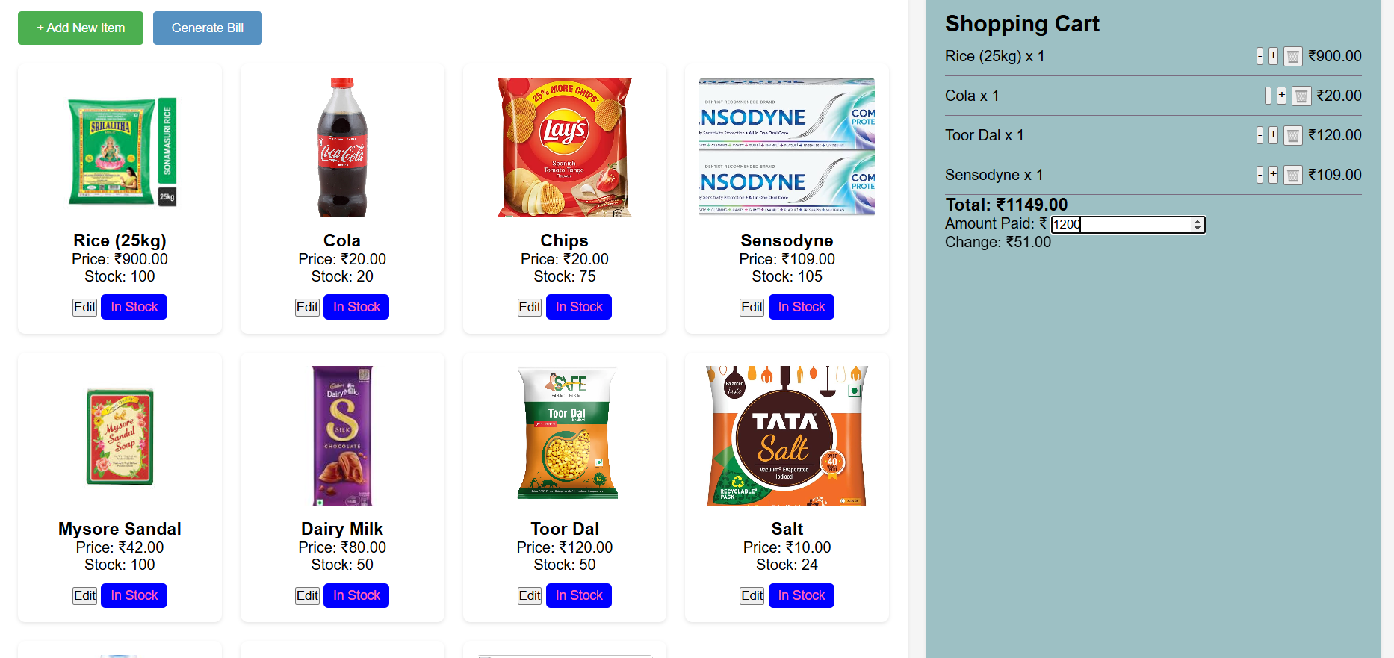

**Test Case 4: Update Cart Quantity**

* Objective: Verify that the quantity of a product in the cart can be updated.
* Precondition: At least one product is in the cart.
* Steps:
  1. Click the "+" button next to the product in the cart.
  2. Click the "-" button next to the product in the cart.
* Expected Result: The quantity of the product in the cart increases or decreases appropriately, respecting stock limits.

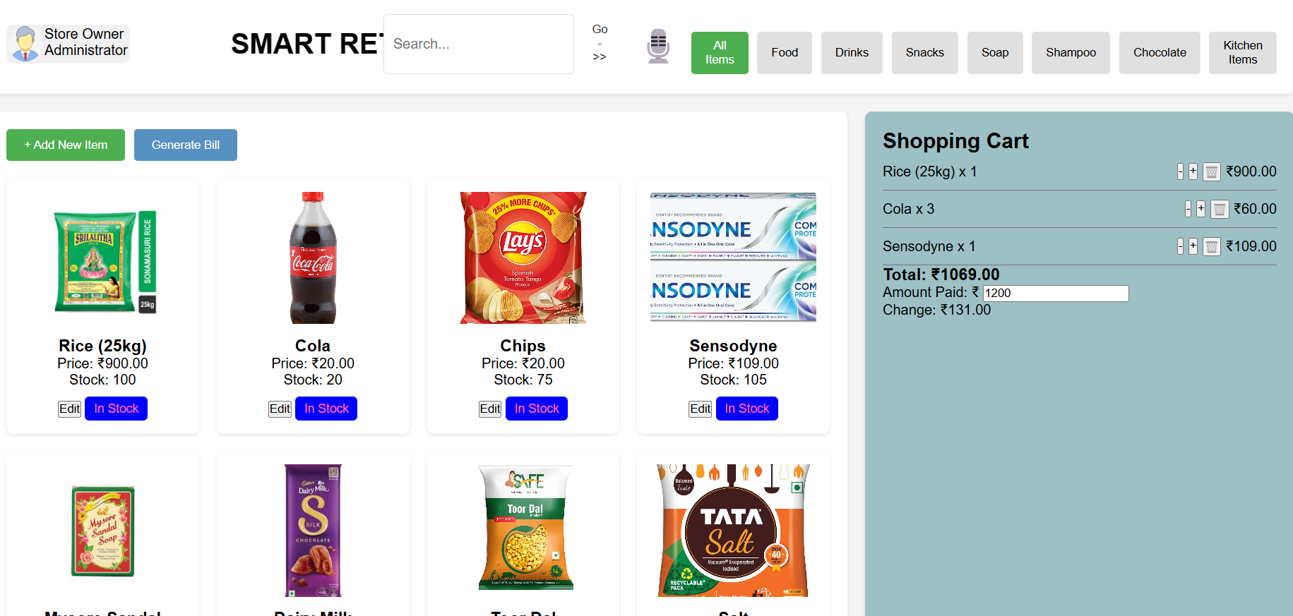

**Test Case 5: Generate Bill**

* Objective: Ensure the billing process calculates the total and updates the inventory correctly.
* Precondition: The cart contains at least one product.
* Steps:
  1. Enter an amount in the "Amount Paid" field.
  2. Click "Generate Bill".
* Expected Result: A bill modal is displayed with accurate details, and the product quantities are updated in the inventory.

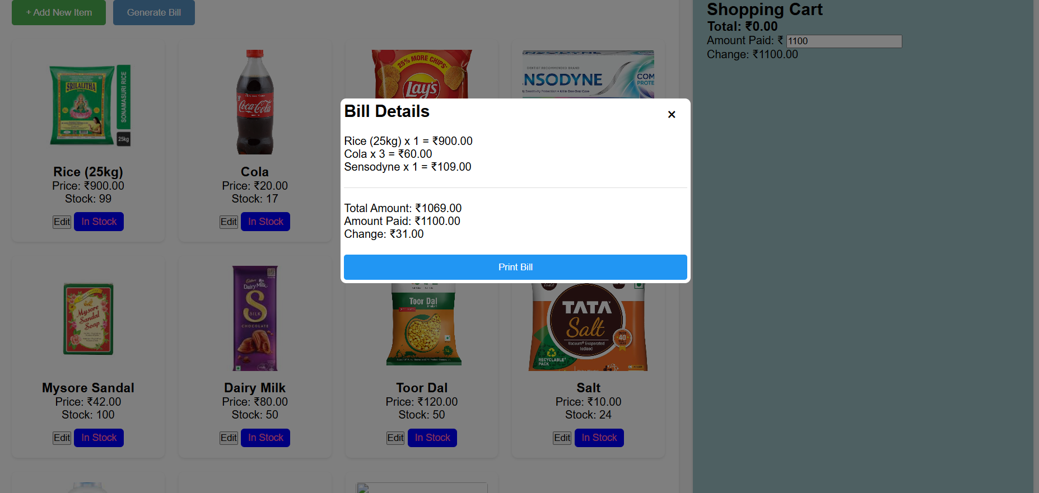

**Test Case 6: Show the image of Food**

. Scenario: The user requests an image of Food.

* Input: User says, "Show the image of Food."
* Expected Outcome:
  1. The assistant recognizes the keyword "Food."
  2. The assistant retrieves and displays an image of Food.
  3. A confirmation message, such as "Here is the image of Food," is shown or spoken

